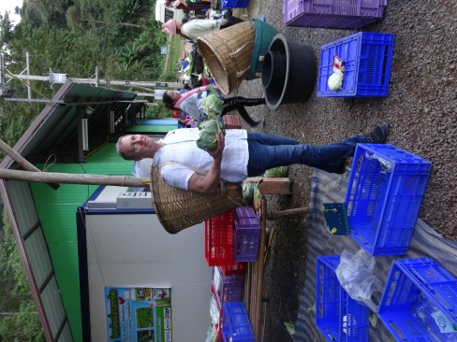
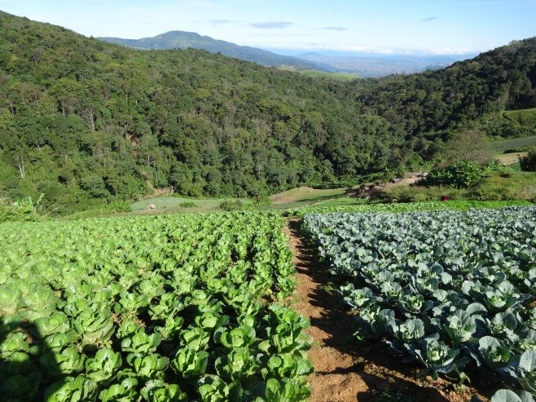
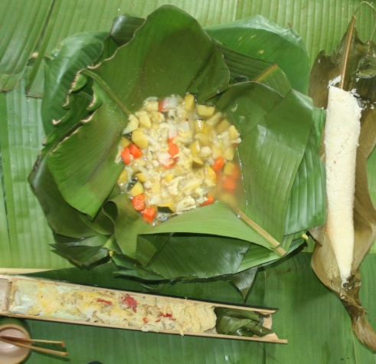
Course period: Winter Session (January 4, 2020 to January 18, 2020)
Session prior to departure-a doodle poll to get the best time for all of the class.
Session after we return-a doddle poll to get the best time for the class.

Credits: Three (3) credits

Pre-requisites: General Biology and General Chemistry (minimum one semester of each)

Faculty Director: Karl R. Matthews, Ph.D. Matthews@sebs.rutgers.edu

Course Objective: This course is designed to appreciate the nexus of food sustainability, food security, and food safety. Students will be exposed to everyday life in Nakhon Pathom, Kanchanaburi, and Phetchaboon. The rich Thai culture will be highlighted across the rural to urban landscape rooted in over 2500 years of tradition. Students will learn the pathway of foods from: farm to processing, warehousing to transport, and retail (open market, supermarket, street vendor, and restaurant) to table.

In this course students will:
- Learn about food pathways.
- Integration of sustainability on the farm and in commercial food manufacturing.
- Students will be actively engaged in educational activities involving food product development; harvest, processing, and transportation of food crops at the interface of food sustainability. food safety, and food security.
- Students will meet and interact with students from Mahidol University engaging in educational and cultural activities.
- Students will visit rural community (Phetchaboon) where sustainable and value added production and processing practices are being implemented with food safety a common linkage.
Course Requirements and Grading
- Completion of at least one semester each of General Biology and General Chemistry
- Students will be provided required reading material prior to and during the course that will be used to facilitate discussion and development of discussion and critical thinking questions which will count toward the grade (25pts).
- Students will maintain a log starting on arrival in Thailand. The log will be entered in Canvas which will be evaluated as part of the grade (35pts). Students should consider experiences related to the culture, people, foods, and academic activities. Students may wish to have discussions with students at each of the Mahidol University campuses to understand student life at each campus.
- Student presentation (15pts)
- After return to the US students will be required to submit a research review paper within one month of return. (25pts)

GRADING FOR THE COURSE
 | SUBMISSION |  | TOTAL POINTS
1 | Logs of Visits/Activities |  | 35
 | - Log 1- Musa- 4 days | 10 points
 | - Log 2- Muka- 3 days | 9 points
 | - Log 3- Petchaboon- 5 days | 16 points
2 | Involvement & Participation |  | 25
3 | Review Paper |  | 25
4 | Presentation |  | 15
TOTAL POINTS FOR THE COURSE |  |  | 100

Attendance and Participation
Students are required to participate in all detailed activities as outlined in the course schedule. Ample free time is available for students to engage in activities on their own.

Disciplinary policy
Students are expected to conduct themselves in an appropriate manner throughout the trip. In short, there is a zero-tolerance policy for student misbehavior while on this trip. Disciplinary action, including receiving a failing grade in the course and potential for immediate return to the US, will be taken as appropriate. Rutgers academic integrity policy (http://academicintegrity.rutgers.edu/) must be abided by when preparing course work.

Itinerary
Day |  | Morning | Afternoon
Day 1 | Jan 4 Saturday MUSA |  | Meet at Mahidol University Salaya Campus. Overview of food exports and industries in Thailand | Free time to explore campus.
Day 2 | Jan 5 Sunday MUSA | Discovering Bangkok – Grand palace (Royal Palace), Emerald Buddha Temple, golden mount. | Open market: Chatuchak Market: Handling practices of raw and prepared food.  Or Tor Kor Flower market
Day 3 | Jan 6 Monday MUSA | Visit Thai Union Food. | Lecture: Safety concerns: On farm safety practices may have negative influence on sustainability
Day 4 | Jan 7 Tuesday MUSA | River tour to plantations producing Gac, Jackfruit, orchids, banana, coconut. | Lecture: On-farm management of sustainable agricultural production practices – Jackfruit, Gac, edible orchids, bananas | Instruction on preparation of student presentations
Day 5 | Jan 8 Wednesday MUSA | Thai cooking | . Salaya Farmer’s market (fruits, vegetables, meat, fish; food safety) | Students work on presentation
Day 6 | Jan 9 Thursday MUKA | Depart to MUKA at 8 AM; Arrive at MUKA; Welcome Luncheon Welcome Ceremony & Orientation (30 min), Campus Tour/ Geology Museum/Herbarium (1 h), Classroom/conference room required by Rutgers (1-2 h), Check-in at Vimandin Resort (Accommodation of MUKA); Excursion at historical sites: Wooden Railway Bridge and Krasae Cave (1-2 h), Dinner: Local Thai cuisine
Day 7 | Jan 10 Friday MUKA | Food Processing @MUKA, Lunch at MUKA Classroom/conference room required by Rutgers (1-2 h), Cultural excursion at Mallika City-Retro-city/ Dress up ancient costumes Traditional Thai Dinner/ Thailand Cultural Shows at Mallika City
Day 8 | Jan 11 Saturday MUKA | Excursion at natural site: Waterfall, Lunch Melon valley /River Kwai International Food Industry (Corn Processing), Classroom/conference room required by Rutgers (1-2 h) Excursion at historical site: Bridge over the River Kwai, closing Ceremony and Farewell Dinner : Thai fusion cuisine, International Road/Night Market
Day 9 | Jan 12 Sunday | Return to Salaya Campus Depart: 8:00 AM Arrive: 10:30AM | Day Off Day Off
Day 10 | Jan 13 Monday Phetchabun | Departure to Phetchabun (7:30 AM; 7 hour drive) | Visit farming operations: Lettuce, cabbage production
Day 11 | Jan 14 Tuesday Phetchabun | Visit processing facility: lettuce and cabbage | Lecture: Local processing and transportation operations. Sustainability practices. Lecture: Value added – “food recycling”.
Day 12 | Jan 15 Wednesday Phetchabun | Cultural activities | Lecture: Water conservation, pest control, post-harvest processing. Lecture: Value added – “food recycling”. | Student work on presentations
Day 13 | Jan 16 Thursday Phetchabun | Departure to Mahidol University Salaya campus (7 hour drive) |  | Student work on presentations
Day 14 | Jan 17 Friday MUSA | Student Project Presentations 20 min talk 10 min Q&A | Student Project Presentations 20 min talk 10 min Q&A
Day 15 | Jan 18 Saturday | Departure to US

