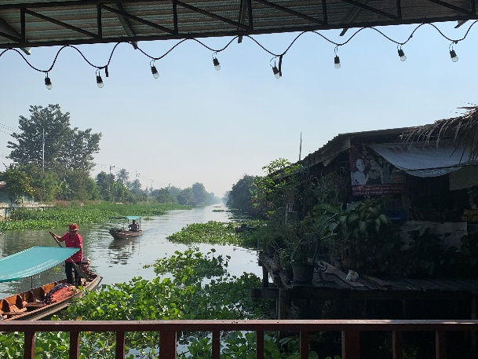
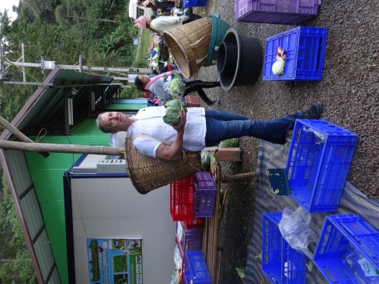
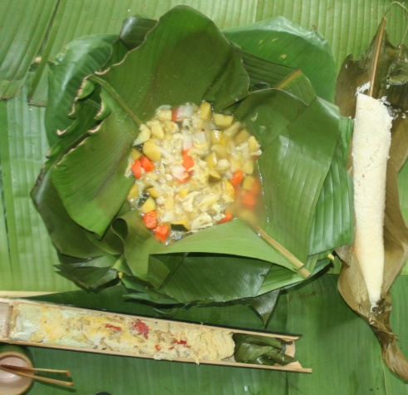
Course period: Winter Session (January 2, 2025 to January 19, 2025)
Students enrolled will be required to meet three times (≤2 hours) prior to departure

Credits: Three (3) credits

Pre-requisites: Permission of the instructor

Faculty Director: Karl R. Matthews, Ph.D. Matthews@sebs.rutgers.edu

Course Objective: This course is designed to appreciate the nexus of food sustainability, food security, and food safety. Students will be exposed to everyday life in Nakhon Pathom, Kanchanaburi, Trat, and Phra Nakhon Si Ayutthaya. The rich Thai culture will be highlighted across the rural to urban landscape rooted in over 2500 years of tradition. Students will learn the pathway of foods from: farm to processing, warehousing to transport, and retail (open market, supermarket, street vendor, and restaurant) to table.

In this course students will:
- Learn about food pathways.
- Integration of sustainability on the farm and in commercial food manufacturing.
- Students will be actively engaged in educational activities involving food product development, harvest, processing, and transportation of food crops at the interface of food sustainability, food safety, and food security.
- Students will meet and interact with students from Mahidol University engaging in educational and cultural activities.
Course Requirements and Grading
- Students will be provided required reading material prior to and during the course that will be used to facilitate discussion and development of discussion and critical thinking questions which will count toward the grade (25pts).
- Students will maintain a log/blog starting on arrival in Thailand. The log/blog will be will be evaluated as part of the grade (20pts). Students should consider experiences related to the culture, people, foods, and academic activities. Students may wish to have discussions with students at each of the Mahidol University campuses to understand student life at each campus.
- Student presentation (30pts)
- After return to the US students will be required to submit a research review paper within one month of return. (25pts)

GRADING FOR THE COURSE
 | SUBMISSION |  | TOTAL POINTS
1 | Log/blog of Visits/Activities |  | 20
2 | Involvement & Participation |  | 25
3 | Review Paper |  | 25
4 | Presentation |  | 30
TOTAL POINTS FOR THE COURSE |  |  | 100

Attendance and Participation
Students are required to participate in all detailed activities as outlined in the course schedule. Ample free time is available for students to engage in activities on their own.

Disciplinary policy
Students are expected to conduct themselves in an appropriate manner throughout the trip. In short, there is a zero-tolerance policy for student misbehavior while on this trip. Disciplinary action, including receiving a failing grade in the course and potential for immediate return to the US, will be taken as appropriate. Rutgers academic integrity policy (http://academicintegrity.rutgers.edu/) must be abided by when preparing course work.

Itinerary
Day |  | Activities: Many activities run from 8AM to 5PM.
Day 1 | Jan 2/3 | Arrive Bangkok
Day 2 | Jan 4 Saturday MUSA | Visit Salaya: Walk to campus, Salaya market, Central Salaya Mall, Bus routes
Day 3 | Jan 5 Sunday MUSA | Free Day: Students on their own. Bangkok – ICONLUX Mall, Chatuchak market, Canal tour (Panfa Leelard Pier, by Wat Sa Ket)
Day 4 | Jan 6 Monday MUSA | Discovering Bangkok – Grand palace (Royal Palace), Emerald Buddha Temple, Golden mount. Or Tor Kor Flower market
Day 5 | Jan 7 Tuesday MUSA | Travel to Sing Buri, visit organic farming operation.  Travel to Ayutthaya historic site
Day 6 | Jan 8 Wednesday MUSA | Thai cooking class
Day 7 | Jan 9 Thursday MUSA | River Tour to Plantations: Production of various crops using traditional and sustainable production practices (Maha Sawat)
Day 8 | Jan 10 Friday MUSA | Depart from Salaya to Koh Chang (Island)
Day 9 | Jan 11 Saturday MUSA | Koh Chang: Visit marine nature reserve, snorkeling, hiking
Day 10 | Jan 12 Sunday MUSA | Depart Koh Chang to Salaya
Day 11 | Jan 13 Monday Nakhon Pathom | Depart Salaya for Kanchanaburi  Campus tour, Excursion to historical sites: Wooden Railway Bridge and Krasae Cave
Day 12 | Jan 14 Tuesday Nakhon Pathom | River Kwai International Food Industry (Corn Processing).  Bridge over the River Kwai, International Road/Night Market  Group dinner
Day 13 | Jan 15 Wednesday MUSA | Depart Kanchanaburi for Salaya
Day 14 | Jan 16 Thursday | Visit integrated organic farm processing center
Day 15 | Jan 17 Friday | Student Presentations
Day 16 | Jan 18  Saturday | Free Day: Students on their own. Nakhon Pathon, Bangkok – ICONLUX Mall, Chatuchak market, Canal tour (Panfa Leelard Pier, by Wat Sa Ket)
Day 17 | Jan 19  Sunday | Return to United States

