Rutgers University, Honors Program

090:293:H3 Brazilian Culture: Conquest to Contemporary

Professor Tatiana Flores Fall 2019
E-mail: tatiana.flores@rutgers.edu Class time: T, 9:50 AM -12:30 PM
Location: Rm 3450 Academic Building

Office: 60 College Avenue, Rm 204
Office hours: Tuesdays after class or by appointment

Course Description

The course explores key tropes that have informed the formation of a particularly Brazilian identity through the lenses of nature and culture. Though these might seem to be contradictory categories, they nevertheless constitute ways for thinking about Brazil’s unique character. Beginning with texts and images related to the conquest, the course takes a panoramic tour of Brazil, through its cultural products and their relation to place. We will study indigenous cultures of the Amazon; Brazil in the European imaginary; colonial artists in the Northeast and Minas Gerais; the representation of race and class through text and image; the conceptualization of modernity in Rio de Janeiro, São Paulo, and Brasilia; and the dichotomy of utopia and dystopia that has recurred in the country’s history. Given the professor’s expertise in art and literature in particular, there will be a strong emphasis on these areas, but architecture, urbanism, film, and music will also be addressed.

The course carries with it a one-credit study abroad component in Brazil. An eight-day program is planned for January 10-18, 2020, with visits to São Paulo and Rio de Janeiro.

Course Objectives
- become grounded in the major themes in the cultural history of Brazil
- gain familiarity with various forms of cultural production in Brazil that derive from Western and non-Western perspectives
- analyze works of Brazilian art and literature through close readings in order to relate them to their historical, social, and cultural contexts
- approach Brazilian cultural production through interdisciplinary humanistic methods.

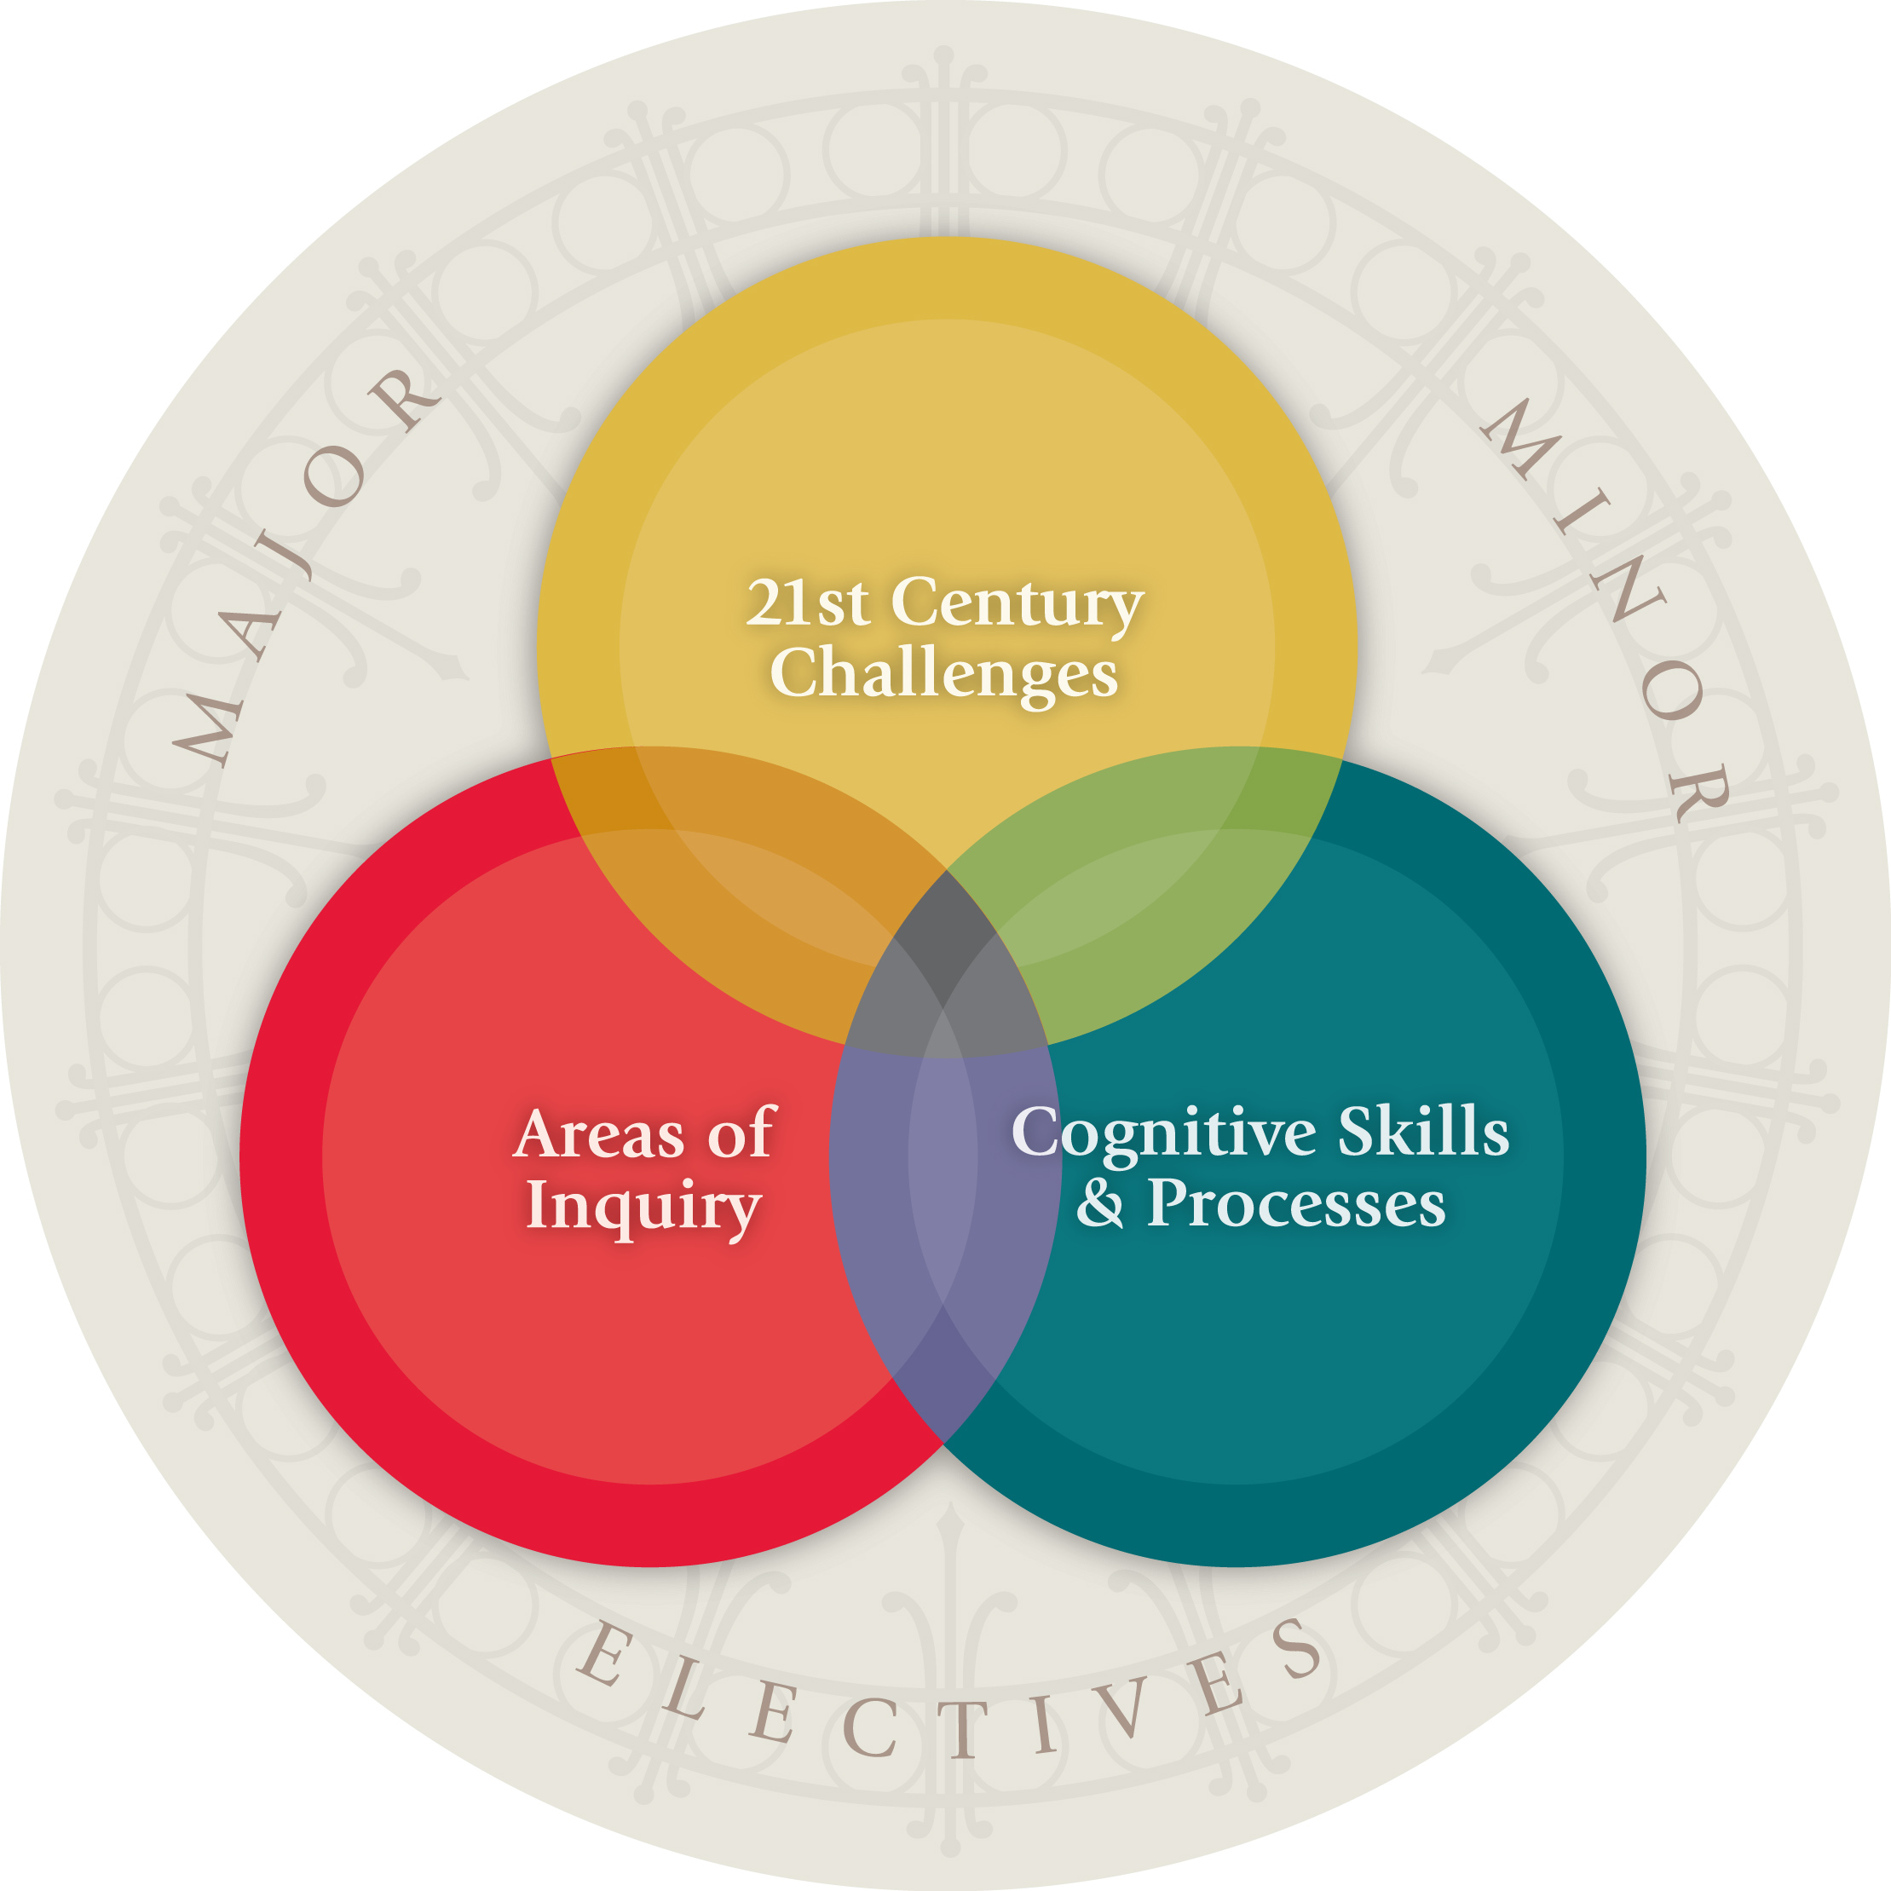
This course satisfies the SAS Core Curriculum Goal: WCD (t, u, v). Student is able to:

(t) – Communicate effectively in modes appropriate to a discipline or area of inquiry
(u) – Evaluate and critically assess sources and use the conventions of attribution and citation correctly
(v) – Analyze and synthesize information and ideas from multiple sources to generate new insights

Textbook
Available for purchase at the Rutgers University bookstore:
- Darlene J. Sadlier, Brazil Imagined: 1500 to the Present. Austin: University of Texas Press, 2008. ISBN: 978-0-292-71857-9

Course Website
Additional readings will be available online through Sakai: https://sakai.rutgers.edu/portal.

The syllabus will also be posted there. Check periodically for announcements, assignments, and schedule changes.

Requirements and Grading

- Regular attendance and active class participation, including field trips and/or other extracurricular activities: 15 %
- 3 short (4-5 page) response papers relating to readings, films, or other topics addressed in class: 45%
- 1 short (10-15 min.) presentation during the semester on a topic related to Brazilian culture: 10%
- Research paper on a topic related to the curriculum and chosen in consultation with the professor: 20%
- Final research presentation (15 mins.): 10%

Academic Integrity

Academic dishonesty will not be tolerated under any circumstances. All students are required to abide by the Rutgers University Academic Integrity Policy. Please review the information online at http://academicintegrity.rutgers.edu/academic-integrity-at-rutgers. Familiarize with the Policy on Academic Integrity and the Code of Student Conduct.

Violations of academic integrity will be reported to the Office of Student Judicial Affairs. When in doubt about what constitutes academic integrity, please ask the professor.

Attendance

Attendance is mandatory. If you expect to miss a class, please use the University absence reporting website https://sims.rutgers.edu/ssra/ to indicate the date and reason for your absence. An email is automatically sent to me. Please note that simply reporting an absence does not excuse you from class. Unexcused absences may result in a lower grade. More than five unexcused absences may result in failure.

Special Accommodations

Students requiring special accommodations should familiarize themselves with the information found on this website: https://ods.rutgers.edu/ and proceed accordingly.

COURSE SCHEDULE
N.B. This schedule and readings are subject to change. Changes will typically be announced on Sakai.

Tuesday, September 3
Introduction: Overview, introductions, expectations, logistics
Film Screening:
- How Tasty Was My Little Frenchman (1978), Nelson Pereira dos Santos, dir.

Tuesday, September 10
“Discovery” and Early Encounters
Readings:
- Sadlier, Chapter 1, “Edenic and Colonial Encounters,” 9-61
- Introduction, “Noble Savages” by John Hemming, and “A Description of the Tupinambá” by Anonymous from the “Origins, Conquest, and Colonial Rule” section of The Brazil Reader: History, Culture, Politics, edited by Robert M. Levine and John J. Crocitti (Durham: Duke University Press, 2009), 11-15, 20-32.
- Pero Vaz de Caminha, “Letter to King Manoel (Discovery of Brazil, 1500)” in Empire in Transition: The Portuguese World in the Time of Camões, edited by Alfred Hower (Gainesville: University Press of Florida, 1985).
Film Screening:
- Amazon Games (2005), Sandrine Leonardelli, dir.

Tuesday. September 17
The Trope of the Cannibal
Readings:
- Sadlier, Chapter 2, “Paradise (Re)Gained: Dutch Representations of Brazil and Nativist Imagery,” 63-83
- Carlos Jáuregui, “Anthropophagy,” Dictionary of Latin American Cultural Studies, edited by Robert McKee Irwin and Monica Szumuk (Gainesville: University Press of Florida, 2014), 22-28.
- Hans Staden, True History: An Account of Cannibal Captivity in Brazil (1547), excerpts
- Jean de Léry, History of a Voyage to the Land of Brazil (1578), excerpts
- Oswald de Andrade, “Manifesto Antropófago” (1928)
- Sara Roffino, “Is Brazil’s Most Famous Art Movement Built on Racial Inequality? A New Generation Argues ‘Yes,’” artnet news, March 13, 2018, url: https://news.artnet.com/art-world/tarsila-part-ii-1238654

Tuesday, September 24
The Visual Culture of Colonialism
Readings:
- Sadlier, Chapter 2, 83-105
- Amy Buono, “Interpretative Ingredients: Formulating Art and Natural History in Early Modern Brazil,” Journal of Art Historiography 11 (Dec. 2014): 1-21.
- John Maddox, “The Aleijadinho at Home and Abroad: ‘Discovering’ Race and Nation in Brazil,” CR: The New Centennial Review 12:2 (Fall 2012): 183-216.
- Suzel Ana Reily, “Remembering the Baroque Era: Historical Consciousness, Local Identity, and the Holy Week Celebrations in a Former Mining Town in Brazil,” Ethnomusicology Forum 15:1 (June 2006): 39-62.
Film Screening:
- The Mission (1986), Roland Joffé, dir.

Tuesday, October 1
Afro-Brazil: Slavery and Colonial History
Library visit (80 minutes): Meet at 9:50 AM in the IHL 413, Alexander Library
Readings:
- Sadlier, Chapter 3, “Regal Brazil,” 106-131
- Section III, “Slavery and Its Aftermath,” The Brazil Reader, 121-147.
- Tania Costa Tribe, “The Mulatto as Artist and Image in Colonial Brazil,” Oxford Art Journal 19:1 (1996): 67-79.

Tuesday, October 8
The Aftermath of Slavery: Race in Contemporary Brazil
Readings
- Gilberto Freyre, “Mestizo Pride,” in Problems in Modern Latin American History: Sources and Interpretations, edited by John Charles Chasteen and James A. Wood. Lanham, MD: SR Books, 2005), 183-186.
- Emilia Viotti da Costa, “The Myth of Racial Democracy,” The Brazilian Empire: Myths and Histories (Chicago and London: University of Chicago Press, 1985), 234-246.
- “Introduction,” A Letter from Brazil, 1918” by José Clarana, “Growing Up Black in Minas Gerais” by Carolina Maria de Jesus, and “Brazil: Study in Black, Brown, and Beige” by Leslie B. Rout, Jr., in “Race and Ethnic Relations,” in The Brazil Reader, 352-364, 367-373.
- Jorge Amado, “How Porciúncula the Mulatto Got the Corpse Off His Back” in Oxford Anthology of the Brazilian Short Story, edited by K. David Jackson (Oxford and New York: Oxford University Press, 2006), 215-222.
Film Screening:
- Black in Latin America – Brazil (2011), narrated and conceived by Henry Louis Gates, Jr.

Tuesday, October 15
National Identity after Independence
Readings:
- Sadlier, Chapter 4, "The Foundations of a National Literary Imaginary,” 132-159.
- Doris Summer, “O Guaraní and Iracema: Brazil’s Two-Faced Indigenism,” Foundational Fictions (Berkeley and Los Angeles: University of California Press, 1991), 138-171.
- Roberto Schwarz, “Misplaced Ideas: Literature and Society in Late-Nineteenth Cenutry Brazil,” Misplaced Ideas: Essays on Brazilian Culture, translated by John Gledson (London: Verso, 1992), 19-32
- Machado de Assis, “The Looking Glass,” in The Alienist and Other Stories of Nineteenth Century Brazil, edited and translated by John Charles Chasteen (Indianapolist: Hackett, 2013), 16-25.

Tuesday, October 22
Intercultural Dialogue
- Neil Safier, “Global Knowledge on the Move: Itineraries, Amerindian Narratives, and Deep Histories of Science,” Isis 101:1 (March 2010): 133-145.
- John Colapinto, “The Interpreter,” The New Yorker (April 16, 2007), http://www.newyorker.com/magazine/2007/04/16/the-interpreter-2
- Carolyn Dean, “The Trouble with (the Term) Art,” Art Journal 65, no. 2 (Summer 2006): 24-32.
- Camila Maroja, “The Persistence of Primitivism: Equivocation in Ernesto Neto’s A Sacred Place and Critical Practice,” Arts 2019, 8, 111: 1-13.

Tuesday, October 29
Modernist Brazil
Readings:
- Sadlier, Chapter 5, “Modernist Brazil,” 184-208.
- Roberto Schwarz, “Brazilian Culture: Nationalism By Elimination,” Misplaced Ideas, 1-18.
- Sara Roffino, “Is Brazil’s Most Famous Art Movement Built on Racial Inequality? A New Generation Argues ‘Yes,’” Artnet News (March 13, 2018). url: https://news.artnet.com/art-world/tarsila-part-ii-1238654.
- K. David Jackson, “Three Glad Races: Primitivism and Ethnicity in Brazilian Modernist Literature,” Modernism and Modernity 1:2 (1994): 89-112,
- Ronaldo Brito, “Fluid Geometry,” in Art in Brazil, 1950-2011, edited by Ronaldo Brito, Guilhermo Bueno, and Sonia Salcedo (Brussels: Europalia, 2011).

Tuesday, November 5
Counterculture and Dystopia
Readings:
- Sadlier, Chapter 7, “From Revolutionary to Dystopian Brazil on Screen,” 234-273.
- Christopher Dunn, “Avant-Garde, Cultura Marginal, and Counterculture in Brazil, 1968-72,” Luso-Brazilian Review 50:1 (2013): 229-252.
- Claudia Calirman, “Naked Man, Flaming Chickens: A Brief History of Brazilian Performance Art” in Deborah Cullen, ed., Arte ≠ Vida: Actions by Artists of the Americas, 1960-2000 (New York: El Museo del Barrio, 2008), 102-113.
- “Tropicalism and Brazilian Popular Music under Military Rule” by Christopher Dunn and “Two Poets Sing the New World” by Jessica Callaway, in The Brazil Reader, 241-247, 491-496.

Tuesday, November 12
Brazilian Music/Guest Speaker: Prof. Micah Oelze, Franklin and Marshall College
Readings: TBD

Tuesday, November 19
Focus on São Paulo
Readings:
- Sadlier, Epilogue, “Land of the Future,” 274-297
- David William Foster, “Introduction: São Paulo, Brazilian Megacity,” São Paulo: Perspectives on the City and Cultural Production (Gainsville: University Press of Florida, 2011), 1-12.
- Sarah J. Townsend, “Parsifal on the Periphery of Capitalism,” The Unfinished Art of Theater: Avant-Garde Intellectuals in Mexico and Brazil (Evanston, IL: Northwestern University Press, 2018), 137-274
- David William Foster, “Downtown in São Paulo with Hildergard Rosenthal’s Camera,” São Paulo: Perspectives on the City and Cultural Production, 53-68.

Tuesday, November 26
No Class – Thanksgiving Holiday

Tuesday, December 3
Wrap-up / Study Day

Tuesday, December 10
Class Presentations on Final Paper

Updated September 3, 2019

