Longing to soak up some culture? You’ll be pleased to know you can still get your creativity fix with these virtual art exhibitions.

The Best Virtual Art Exhibitions

British Surrealism
You can now experience Dulwich Picture Gallery’s acclaimed British Surrealism exhibition for free online, with a virtual walk through produced with The Net Gallery. The exhibition celebrates the official centenary of Surrealism in 1920 – in which French writer and founder André Breton began experimenting with surrealist writing – and all that the movement embodies, such as dreams, mischief, desire and the unconscious. Over 70 artworks from 42 artists are included in the collection, including Leonora Carrington, Francis Bacon, Henry Moore, Paul Nash and many more. dulwichpicturegallery.org.uk

Every Picture Tells a Story
See behind the scenes of iconic celebrity photographs in the first retrospective of works by British photographer Terry O’Neill since he passed away in November last year. Though the exhibition launches in Gstaad’s Maddox Gallery, it’s also being displayed in an immersive virtual gallery for viewers worldwide. The collection includes a recently colourised snap of Frank Sinatra on the Miami Boardwalk, a windswept Brigitte Bardot posing with a cigar between her teeth, Faye Dunaway the morning after her Oscar win and much more, with each image accompanied by stories from Terry’s perspective. maddoxgallery.com

Another’s Tongue
This month White Cube presents a new online exhibition of works from Kenyan-British artist Michael Armitage. The collection features a broad range of subjects – from the expansive Kenyan landscape and its wildlife to life on the streets in urban East Africa. A variety of different voices are displayed in his character sketches – hence the exhibition title, ‘Another’s Tongue’ – including street performers, prophets and costumed crowds at Kenyan election rallies. whitecube.com

The Stillness of Life
Acclaimed photojournalist Sir Don McCullin is presenting an online exhibition of platinum prints to tie in with the reopening of ‘The Stillness of Life’ at Hauser & Wirth Somerset. The digital curation features a collection of landscape imagery – from flooding meadows in Somerset to the Northern Arctic in Svalbard Archipelago. Available from 2 July. hauserwirth.com

The Human Figure
Michael Werner Gallery is reopening in July with a new exhibition titled About the Human Figure, running in tandem with an online exhibition. This will explore different depictions of the human figure in art, with paintings and sculptures from a range of artists including James Lee Byars, Enrico David, Peter Doig and Florian Krewer. Online exhibition live now. michaelwerner.com

Mushrooms: The Art, Design and Future of Fungi
If you thought there couldn’t possibly be an entire exhibition dedicated to the mighty shroom, think again. Somerset House is hosting a one-of-a-kind showcase exploring and celebrating fungi in all its wondrous forms, featuring the work of more than 40 renowned artists, designers and musicians including artist Cy Twombly, beloved author Beatrix Potter and composer John Cage. Whilst the arts centre is temporarily closed, a virtual tour of the exhibition is now available to explore online. somersethouse.org.uk

Anno’s Journey: The World of Anno Mitsumasa
Whilst a visit to London’s Japan House might be off the cards, a (virtual) visit to their latest exhibition is not. Explore the life and visionary works of celebrated Japanese illustrator Anno Mitsumasa in the culture hub’s first online showcase (using 3D technology), comprising 89 vivid Japanese paintings, watercolours, papercuts and more. japanhouselondon.uk

Arshile Gorky and Jack Whitten
In a tribute to Arshile Gorky, an early adopter of the Abstract Expressionism movement that would come to define much of 20th century American art, experimental visual artist and sculptor Jack Whitten deemed him “my first love in painting”. In this virtual exhibition presented by Hauser & Wirth, works by both are shown side by side, highlighting the similarities in the approaches of these two master artists of the last century. Sales from the exhibition will support the COVID-19 Solidarity Response Fund. hauserwirth.com

TRATE: Technicolour Malaise
Canadian artist TRATE (who works under an alias) is showcasing his third London exhibition at Soho gallery 15 Bateman Street, an evocative and vibrant collection of his signature large-scale figurative paintings. In light of the current situation, the exhibition is currently available to view via virtual studio tours. aliastrate.com

Andy Warhol
Delve into the fantastical world of Andy Warhol at the Tate Modern’s highly anticipated 2020 retrospective. From his iconic pop images dedicated to Marilyn Monroe, to the Ladies and Gentlemen series (exhibited for the first time in 30 years) and an array of unseen pieces, this is an eclectic must-see showcase for Warhol enthusiasts world-wide. Fortunately, the Tate Modern has released an online tour of the long-awaited exhibition, available to access via the gallery website.

Peter Clark: Just Trying to Have Me Some Fun
From exotic birds and wild flowers to a ‘dashingly debonair’ daschund, Peter Clark’s joyful and vibrant collages are exactly the kind of artistry we need right now. Explore the artist’s latest collection Just Trying to Have Me Some Fun in a virtual exhibition hosted by St. James’s Portland Gallery. storage.net-fs.com

The Enchanted Interior
Delight in the works of over 50 established artists in The Enchanted Interior, an artistic exploration of the historic impression of women in ‘enclosed and ornate spaces’. A fusion of paintings, photography, film and more, from the Pre-Raphaelites to present day examine the concept of the ‘gilded cage’ in this thought-provoking exhibition. The major exhibition is available to view via the City of London website and social media platforms through a series of images and curator-led virtual tours. cityoflondon.gov.uk

Celebrating Raphael
Online arts platform Musement has launched a brand-new virtual exhibition dedicated to world-renowned Italian artist Raffaello Sanzio (also knows as Raphael). The innovative gallery will showcase some of the Renaissance artist’s most significant works, marking the 500th anniversary of his death. musement.com

The Dividing Line
Presented by virtual reality art gallery Fluorescent Smogg, this immersive show brings together some of the world’s leading contemporary artists – working in a range of mediums from screenprint to video – to ask some incredibly prescient questions. Can a traditional gallery experience be assimilated in virtual reality, and are real spaces needed in a digital world simmering with ‘deep fakes’? Constructed using the latest 3D rendering, the exhibition aims to explore these issues and more, while donating 10% of profits to mental health charity Mind. What’s more, the virtual gallery has been extended until the end of July, now featuring a brand-new pop-up titled The Trellick Project. The additional space will transform every few weeks, showcasing an array of limited edition and bespoke works from the likes of Ben Eine, Rick Griffin and Ralph Steadman. fluorescentsmogg.com

HERSTORY
Maddox Gallery’s female-led exhibition HERSTORY showcases the works of budding and established female international artists. Aiming to shift the conversation surrounding women in art, the significant exhibition features artworks from the likes of Instagram art sensation Sophie Tea, American visual artist Beau Dunn, painter Lily Kemp, and multidisciplinary artist Lauren Baker, to name but a few. View the exhibition catalogue from home via the gallery website. maddoxgallery.com

LOVE, ART, LOSS: The Wives of Stanley Spencer

Stanley Spencer Gallery, Maidenhead
A new exhibition at the Stanley Spencer Gallery examines the intriguing relationships artist Stanley Spencer had with his two wives, Hilda Carline and Patricia Preece. Featuring over 25 works, the show examines the bizarre love triangle that existed between them, as well as looking at the effect the two women had on Spencer’s art. 15 August – Autumn 2021. stanleyspencer.org.uk

Ancient Deities

Arusha Gallery, Edinburgh
Curated by Rhiannon Rebecca Salisbury and Agnieszka Prendota, Arusha Gallery’s new exhibition sees eighteen selected artists reflections of an ancient deity. Presented physically in the gallery as well as online, the collection is all about mystical entities: gods, demons and spirits all feature. ‘I wanted to invite a group of artists whose work excites and inspires me to come together and invoke a whole world of otherness, apart from the seen reality around us,’ says Salisbury. ‘Calling upon or selecting an Ancient Deity to make an artwork from is an entirely subjective process. Whether your belief in the Deity is literal, or you resonate with the ideas they form has come to symbolise, each artist’s choice and research reveals something about their current position and standing in today’s world.’ 10 September – 18 October 2020, arushagallery.com

Young Rembrandt

Ashmolean Museum, Oxford
Uncover the history behind one of the most influential visual artists, Dutch painter Rembrandt, at the Ashmolean Museum’s Young Rembrandt exhibition. The first retrospective ever dedicated to the artist’s early years (624–34) – comprising of 24 authentic works amongst those from his chief contemporaries, international and private collections – uncover the evolution of an artist destined for universal recognition. Reopening 10 August, ashmolean.org

Beyond The Brotherhood

Russell-Cotes Art Gallery & Museum, Bournemouth
The Pre-Raphaelite movement has impacted and inspired art and culture since its very foundation in 1848. Beyond the Brotherhood explores the movement’s effect on contemporary fantasy works, from the likes of Game of Thronesto Lord of the Rings. 21 February until 27 September 2020, russellcotes.com

Whose Future
A month-long outdoor art exhibition inspired by the Black Lives Matter movement has opened in Bristol, taking over over spaces that would usually be given over to billboards. Curated by Rising Arts Agency, the exhibition – titled Whose Future – showcases works from 40 young creatives, giving platform to the city’s voices while also asking important questions about its future. Running until late August, rising.org.uk
- 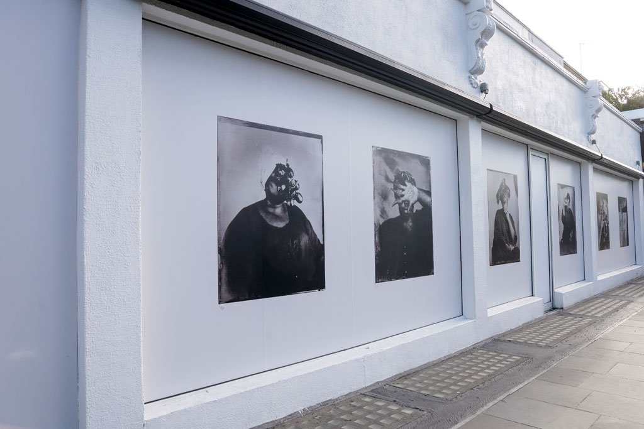

Breath is Invisible

Notting Hill, London
The first of three exhibitions in a new public art project, Breath is Invisible showcases works by Khadija Saye, the young Gambian-British artist who tragically lost her life in the Grenfell Tower fire in 2017, aged just 24. Nine large-scale prints are shown across the façade of 236 Westbourne Grove in Notting Hill, all of which explore the migration of traditional Gambian spiritual practices. Saye said of the works: ‘The series was created from a personal need for spiritual grounding after experiencing trauma. The search for what gives meaning to our lives and what we hold onto in times of despair and life changing challenges.’ 7 July – 9 October.
The second series, to be invisible, is a 3D soundscape inspired by the Black Lives Matter movement. Presented by Martyn Ware and Zachary Eastwood-Bloom, the exhibition features a reinterpretation of the Curtis Mayfield song ‘To Be Invisible’ from 1974, with a spoken word overlay by actor and singer Haroon Yamou. In tandem, artist Zachary Eastwood-Bloom used audio components of the composition to create a generative 3D animation to make the invisible, visible. 11 August – 4 September, breathisinvisible.com

Anish Kapoor
Houghton Hall, Norfolk
Head to Norfolk to see the largest UK exhibition of outdoor sculptures by celebrated British sculptor Anish Kapoor. The exhibition – which was originally due to open in March – features 24 seminal works from Kapoor, including Sky Mirror, a five-metre diameter mirror of stainless steel that reflects and transforms the space around it. 12 July – 1 November 2020, houghtonhall.com

Carry Akroyd, Inland

The Jerram Gallery, Dorset
Landscape artist Carry Akroyd has traversed rural England to produce her softly coloured, recognisable paintings, which are often found gracing book covers. Using mixed media as well as oils and watercolour, she deftly captures the dramatic changes in field patterns and geology across counties from Dorset to the Cotswolds. 10–24 October, jerramgallery.com

10 European Museums You can Visit From Home

Festival season is going to look a little different this year. We sadly won’t be enjoying the vibrant atmosphere of our favourite summer fiestas – but we can still have a taste of the action by tuning into one of the virtual festivals taking place. Read on for some of the best, spanning the worlds of music, food, literature and theatre.

Tune in Nature at Natural History Museum
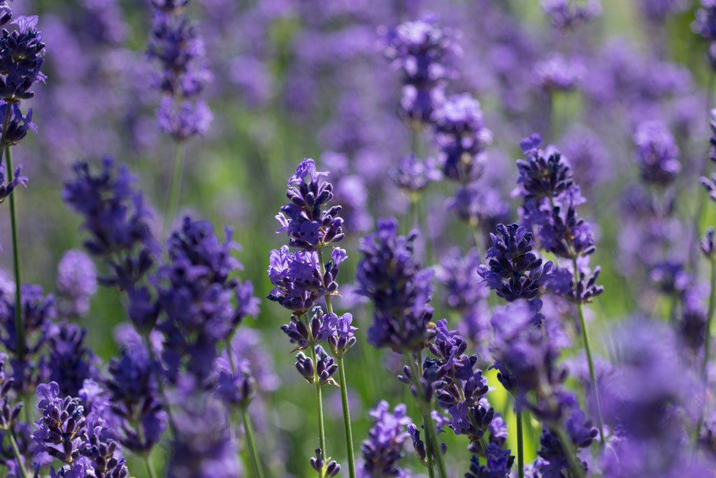
Pukka Herbs
Connect with local wildlife, test your knowledge of natural history and learn about the life cycle of plants at Tune in Nature, a new virtual festival launching at the Natural History Museum. Created in collaboration with Pukka Herbs, the festival aims to connect people with nature, with a jam-packed programme of free digital events taking place across the two-week period. There are activities for all the family, including Pukka Herbs’ ‘how to’ video series, which focuses on three pollinator-friendly herbs used in their organic teas. There’s also a YouTube quiz on natural history, and an event titled Noisy Nature which encourages families to use their sense of hearing to connect with local wildlife.
When? 27 July – 9 August 2020
How? Visit nhm.ac

Foraging Fortnight
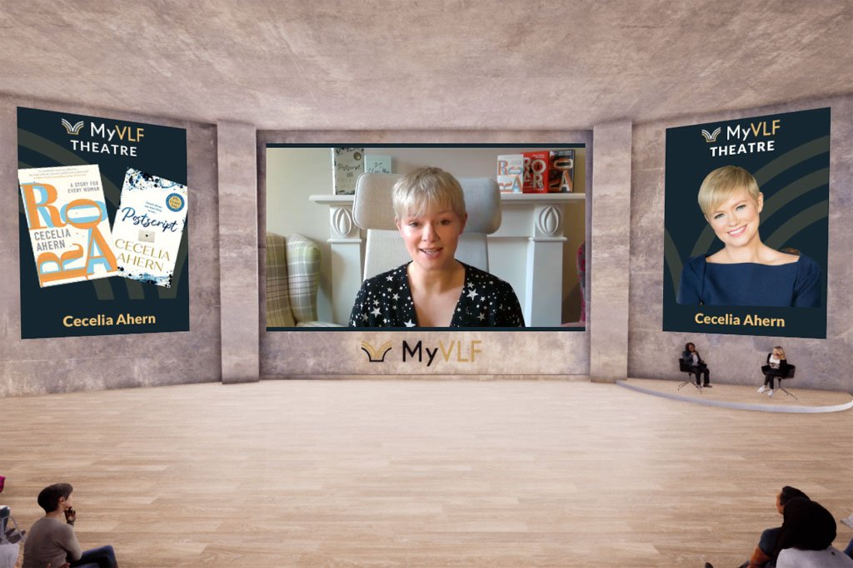
Free global virtual literary festival venue My VLF was launched in April 2019, well before coronavirus came into our lives. It was born out of a love of books, and the desire to connect readers and authors without the need to travel or spend money attending a literary event. Now, of course, it’s more relevant than ever. Events take place frequently throughout the year: next up is a discussion with Katie Fforde and Elizabeth Noble on all things books, writing and inspiration.
When: Available to watch on the website now
How: Sign up to My VLF for free, and you’ll have access to all events via myvlf.com

