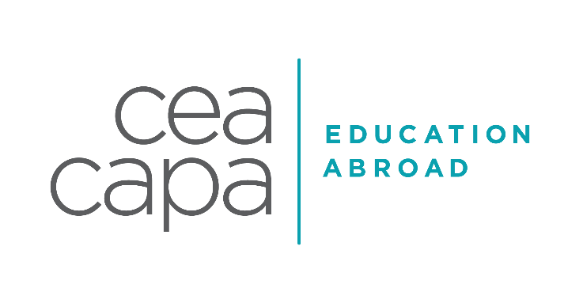

LONDON SAMPLE INTERNSHIP LIST HEALTHCARE

INDUSTRY DESCRIPTION
The healthcare industry in the UK has many laws and legislations that will impact the level and type of opportunities available to undergraduate students. For many roles, especially those requiring “hands on” responsibilities, there are regulations that stipulate that individuals must have achieved certain qualifications. However, CEA CAPA has developed meaningful placements with a range of organisations that can provide first class opportunities to support and develop the students understanding of healthcare practices, cultural differences as well as technical skills. Placements will vary from small private facilities, community organisations through to large NHS hospitals. Students will need to have a relevant academic background and related work experience or undertaken extracurricular activities in the healthcare field to be accepted by a host site.
EXAMPLES OF PAST PLACEMENTS
Please note that the following sites are a brief cross-section of current CEA CAPA internship host sites and should not be considered as a guaranteed location for your placement. All internship & service-learning placements will be dependent upon each individual applicant’s application documents, prior experiences, demonstrated skills and their aspirations and goals.

Cavendish Imaging | Cavendish Imaging is a medical imaging company specialised in cone beam CT imaging and anatomical model production. Both activities focus on helping clinicians plan the patient’s surgery and shorten surgery-time. Cavendish receives referrals from both the private and NHS sectors. Placements are focused on healthcare administration and commercial development.
Body Representation Laboratory, Department of Psychological Sciences, Birkbeck  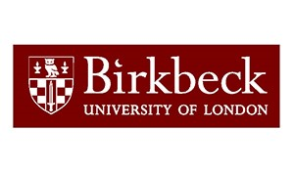 | The BodyLab is part of the Mace Experimental Research Laboratories in Neuroscience (MERLiN) in the Department of Psychological Sciences at Birkbeck, University of London. As well as studying typical brain development, it is one of the few laboratories in Europe that studies brain functioning. Placements are research orientated and students will receive mentoring from some of London’s finest professionals.
Kings College Hospital  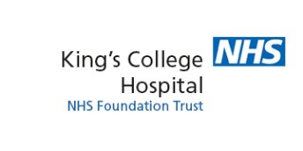 | King’s College Hospital NHS Foundation Trust is one of London’s largest and busiest teaching hospitals, with a unique profile of strong local services and a focused set of specialist services. Kings are recognised nationally and internationally for their work in liver disease and transplantation, neurosciences, cardiac and haemato-oncology, although placements have been provided in many other fields.
NAZ  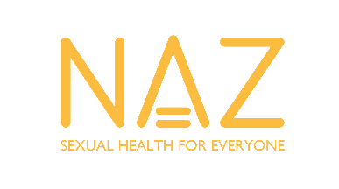 | NAZ aims to educate and empower communities to face up to the challenges of sexual health and HIV, and to mobilize the support networks that exist for people living with HIV/AIDS. NAZ also provides training services to voluntary, community and statutory organisations as well as a wide range of resources. Placements have been available within grant funding, community outreach and volunteer coordination programs.
The Royal Free Hospital Children's School | The Royal Free Hospital Children's School is a community Special School for pupils aged 5 to 16. They offer high quality education for all children who are inpatients at the Royal Free Hospital. They also provide places for a limited number of children who are not in-patients but who are receiving support from medical or mental health services and may benefit from attending our school on a daily basis. The school operates within a multidisciplinary framework; working closely with a range of professionals including consultant doctors, mental health professionals, physiotherapists, speech therapists and other agencies. Interns may be required to provide efficient and effective classroom support and, where appropriate, administrative support. If an intern has a particular interest in some of the clinical activities the school has access to and collaborates with dieticians working with eating disorders, Speech and Language Therapist, Physiotherapists, Mental Health
The Nordic Balance | The Nordic Balance team provides a holistic and intuitive approach to well-being, wrapping each person in a circle of care. This integrated approach couples an extensive range of natural therapies with knowledge and experience to offer personal training and treatment plans tailored to individual needs. Interns support the overall smooth running of the practice and gain real-world insights from the practitioners they support.

POTENTIAL PROJECT OPPORTUNITIES
Project opportunities will be dependent upon the current needs within the organisation and the demonstrated skills and abilities shown by each intern. It is imperative to remember that project opportunities will develop over time and throughout internship placements. Projects may include but are not limited to:

Advocacy Campaigns | Drafting Documents
Client Observations | Industry/Medical Research
Community Outreach | Office Administration
Database Management | Social Media Development
Developing Reports

TRANSFERABLE SKILLS
It is essential to maximise every opportunity within the internship placements. If tasks and duties are approached in a professional manner, interns can take away additions skills and abilities that will be of benefit to their personal and professional development. Transferable skills set include but are not limited to:
Analytical Skills | IT Technical Skills
Business Acumen | Networking
Commercial Awareness | Presenting
Communications | Problem Solving
Customer & Client Service Skills | Project Leadership
Information Gathering | Teamwork
Interaction & Liason Skills | Time Management

NACE CAREER READINESS COMPETENCIES
Through our pre-departure advising, internship, Global Internship Course and extra-curricular activities, CEA CAPA embeds and works to help students develop the following NACE Competencies:
1. Career and Self-Development: The ability to demonstrate requisite core competencies to develop oneself and one’s career through continual personal and professional learning, awareness of one’s strengths and weaknesses, navigation of career opportunities, and networking to build relationships within and without one’s organization
2. Communications: The ability to receive, interpret and articulate information and ideas clearly and effectively.
3. Critical Thinking: The ability to identify and respond to needs based upon an understanding of situational context and logical analysis of relevant information.
4. Equity and Inclusion: To develop an understanding of oneself, others and to embrace and appreciate diverse and complex perspectives, values and beliefs.
5. Leadership: The ability to recognize and capitalize on personal and team strengths to achieve organizational goals.
6. Professionalism: The ability to acknowledge work environments differ greatly, understand, and demonstrate effective work habits, and act in the interest of the larger community and workplace.
7. Teamwork: The ability to build and maintain collaborative relationships to work effectively toward common goals, while appreciating diverse viewpoints and shared responsibilities.
8. Technology: The ability to understand and leverage technologies ethically to enhance efficiencies, complete tasks, and accomplish goals.

