

**Masters Programme**

**In Library and Information Science**

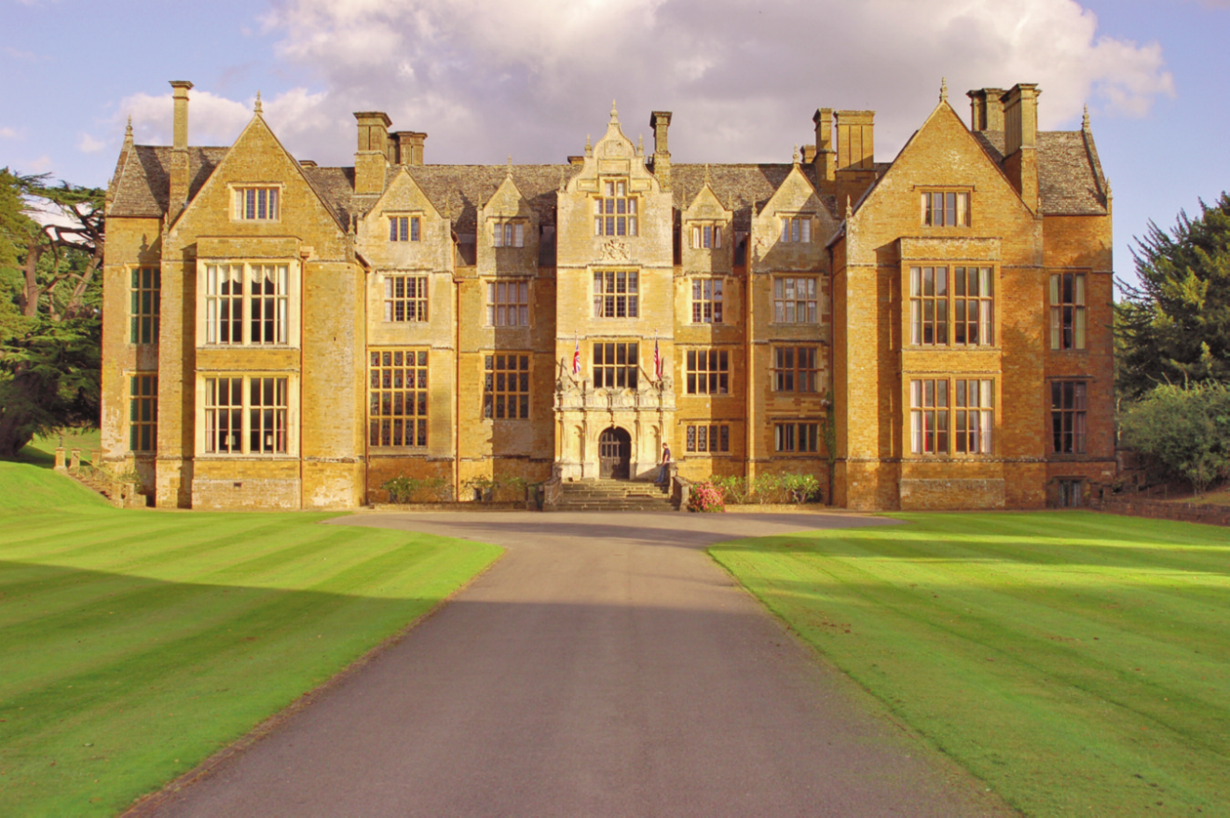

**RUTGERS UNIVERSITY**

**DEPARTMENT OF LIBRARY & INFORMATION SCIENCE**

**LIBRARY GROUP**

**Masters of Information (MI)**

British Collections and Archives

**Tuesday 30th July – Friday 9th August 2024**

**Venue: Lecture Hall**

(unless otherwise stated)

**MONDAY 29th JULY**

United Airlines Flight 940 (From Newark to London-Heathrow) departs at 10pm (This is the day before the course starts in England)

**TUESDAY 30th JULY**

10:10amUAFlight 940 due to arrive at Heathrow Airport, Terminal 2

Group met by College representative and transported to Wroxton College

12:45pm Expected time of arrival at Wroxton College

1.30pm Lunch served in the Dining Room, Carriage House

2.15pm Transport departs for afternoon trip into Banbury to enable participants

to avail themselves of banking, shopping

4.00pm Transport departs Banbury to return to Wroxton College

4.30-4.50pm Afternoon Tea served in the Buttery, Carriage House

5.00pm ***Welcome Introductory Briefing and Tour*** *-* Regency Room

- Dr Nicholas D. J. Baldwin,

Dean, Wroxton College

6.15-7.00pm **UNIT 1:TUTORIAL #1** **& Introductory Meet & Greet** **Session***–* The Buttery

7.00pm ***Welcome Buffet served in the Dining Room, Carriage House***

**WEDNESDAY 31st JULY**

8.00-8.50am Breakfast served in the Dining Room, Carriage House

9.00-10.45pm **UNIT 2: BRITAIN AS A FOREIGN COUNTRY**

and - Dr. Nicholas D. J. Baldwin, - Lecture Hall

11.15-12.15pm Dean, Wroxton College

(10.45-11.15am Morning Coffee served in the Buttery, Carriage House)

12.20pm Group photograph

- Assemble on the Abbey front steps (in Great Hall if raining)

12.25pm Lunch served in the Dining Room, Carriage House

1.30-2.30pm **UNIT 3: A TOUR OF THE COLLEGE GROUNDS (Weather permitting)**

- Andrew Rose, Meet outside the Carriage House

Librarian, Wroxton College

2.30pm-3.30pm **UNIT 4: TUTORIAL #2**

- Dr. Marie Radford - Lecture Hall

3.30-4.00pm Afternoon Tea served in the Buttery, Carriage House

4.00-6.00pm **UNIT 5: FILM PRESENTATION: The Imitation Game** - Lecture Hall

6.00-7.00pm ***Mediaeval Costumes for hire from the Basement Store Room***

*(This is the only time available for the hire of costumes.)*

*(Costume hire is £10.00 in cash and is optional)*

7.00pm Dinner served in the Dining Room, Carriage House

**THURSDAY 1st AUGUST**

8.00-8.50am Breakfast served in the Dining Room, Carriage House

9.00-10.00am **UNIT 6: THE WROXTON LIBRARIES &**

**A HISTORY OF LIBRARIES IN THE UK**

- Andrew Rose, - Lecture Hall

Librarian, Wroxton College

10.00-11.00am **UNIT 7: EXPLORING THE WROXTON ARCHIVES**

- Andrew Rose, - Guilford Library

Librarian, Wroxton College

11.00-11.30am Morning Coffee served in the Buttery, Carriage House

11.30am-1.00pm **UNIT 8:** **DIGITAL PRESERVATION & ARCHIVES**

- Hannah Jones, - Lecture Hall

Sector Development Manager East and Arts at the National

Archives

1.00pm Lunch served in the Dining Room, Carriage House

2.00-3.00pm **UNIT 9:** **GENERAL DATA PROTECTION REGULATION**

**(PRIVACY ISSUES) & ARCHIVES**

- Hannah Jones, - Lecture Hall

Sector Development Manager East and Arts at the National

Archives

3.00-3.30pm Afternoon Tea served in the Buttery, Carriage House

3.30-5.30pm **UNIT 10: TRENDS IN ACADEMIC LIBRARIES IN THE UK & OPEN ACCESS**

- Stephen Pinfield, Ph.D., - Lecture Hall

Professor & Senior Lecturer at the Information School, Sheffield University

* * * * * * * *

***THE WROXTON MEDIAEVAL BANQUET***

*7.00pm Gather Yee in Buttery*

*7.30pm Come to Board in Dining Room*

*8.30-11.00pm Bar Open*

* * * * * * * *

**FRIDAY 2nd AUGUST**

8.00-8.50am Breakfast served in the Dining Room, Carriage House

9.00-10.30am **UNIT 11: A HISTORY OF OXFORD AND OXFORD UNIVERSITY:**

**FROM 55 BC TO 2024**

- Dr. Guy Fielding, - Lecture Hall

University of Oxford

10.30-11.00am Morning Coffee served in the Buttery, Carriage House

11.00am Transport departs for afternoon/evening in Oxford

12noon ETA Oxford

*- Participants will be provided with a packed lunch*

12.00-2.30pm Free time in Oxford.

2.30-4.30pm **UNIT 12:** **THE WESTON LIBRARY SPECIAL COLLECTIONS**

- Mike Webb,

Curator of Early Modern Archives & Manuscripts

(Meet at the Weston Library, Blackwell Hall by the Information Desk)

6.00pm Transport departs Oxford from this afternoon’s drop off point to return to

Wroxton College

7.00pm ETA Wroxton College

7.30pm Dinner served in the Dining Room, Carriage House

**SATURDAY 3rd AUGUST**

7.30-8.00am Breakfast served in the Dining Room, Carriage House

8.00am Transport departs for day trip to London

(*Participants are responsible for their own lunch and dinner arrangements)*

10.00am ETA London

11.00pm Transport departs London to return to Wroxton

12.30am ETA Wroxton

Tea, Coffee and light refreshments served in the Buttery, Carriage House

**SUNDAY 4th AUGUST**

8.00-8.50am Breakfast served in the Dining Room, Carriage House

10.30-11.00am Morning Coffee served in the Buttery, Carriage House

12.30pm Lunch served in the Dining Room, Carriage House

3.45-4.15pm Afternoon Tea served in the Buttery, Carriage House

6.00-7.00pm **UNIT 13: TUTORIAL #3**

- Dr. Marie Radford - Lecture Hall

*(Sign up for optional packed lunch for Tuesday 6th August in Oxford)*

7.00pm Dinner served in the Dining Room, Carriage House

**MONDAY 5th AUGUST**

7.30-8.15am Breakfast served in the Dining Room, Carriage House

8.15am Transport departs for Bletchley Park

10.15am-12.30pm **UNIT 14: VISIT TO BLETCHLEY PARK**

12.30pm Transport departs Bletchley Park for afternoon visit to Stratford upon Avon

*- Participants will be provided with a packed lunch*

- *Participants are responsible for their own dinner arrangements*

2.00pm ETA Stratford upon Avon

2.30-4.00pm **UNIT 15: VISIT TO HARVARD HOUSE, THE SHAKESPEARE BIRTHPLACE TRUST**

- Caroline Marchant-Wallis, Collections Librarian

- Dr Jennifer Waghorn, Lecturer in Shakespeare Studies

Free time in Stratford upon Avon

6.45pm 7.00pm Assemble in the foyer of the Royal Shakespeare Theatre to attend the

Royal Shakespeare Company production of ***‘The School for Scandal’***

(performance begins at 7.30pm and is scheduled to end at 10.30pm)

**1770s London, where the aristocracy’s morals have plunged lower than the necklines on the women’s gowns. The vicious Lady Sneerwell enjoys ruining reputations for pleasure, and her latest target is the young bachelor Charles Surface  — why should this pretentious little rake inherit his uncle’s fortune? Together with Charles’ conniving brother Joseph, Sneerwell orchestrates an elaborate scheme of intrigue and infidelity that’s sure to ruffle all the right feathers — hopefully.**

After Shakespeare but long before *Bridgerton*, there was *The School for Scandal*, Sheridan’s brilliantly biting comedy of manners in five acts. This new production — styled to the nines with period flair — promises an exuberant feast of big wigs and even bigger laughs.

10.30pm Transport departs Stratford to return to Wroxton

11.00pm ETA Wroxton

**TUESDAY 6th AUGUST**

8.00-8.50am Breakfast served in the Dining Room, Carriage House

8.50-9.50am **UNIT 16: TUTORIAL #4**

- Dr. Marie Radford - Lecture Hall

10.00am Transport departs for Oxford

*- Participants may have signed up for a packed lunch*

11.00am ETA Oxford

11.30-12.30pm **UNIT 17: VISIT TO OXFORDSHIRE COUNTY PUBLIC LIBRARY**

- Tour of the Library conducted by Ian Hunter, Librarian, Reading Health & Culture

12.30-4.00pm Free time in Oxford.

- *You may wish to tour the Bodleian, Christ Church or the Ashmolean*

4:00pm Transport departs Oxford from this afternoon’s drop off point to return to

Wroxton College

5.00pm ETA Wroxton

7.00pm Dinner served in the Dining Room, Carriage House

**WEDNESDAY 7th AUGUST**

6.30-7.30am Early Breakfast served in the Dining Room, Carriage House

7.30am Transport departs for London:

*- Participants will be provided with a packed lunch*

9.30am ETA Kew

**UNIT 18: VISIT TO THE NATIONAL ARCHIVES, KEW**

10.00-11.30amTour of the Reading Rooms and the Library,

*(****Please note:*** *coats, bags, purses, pens, etc. must be left in the locker area*

*as they are not allowed in the Reading Room)*

11.45am Assemble at the coach: Transport departs for St. Pancras, London

**UNIT 19: VISIT TO THE BRITISH LIBRARY, ST. PANCRAS, LONDON**

1.00pm ETA St. Pancras. Free time.

2.15pm Meet in the British Library lobby

near the Information Desk by the main entrance

2.30-3.30pmTour of the Library conducted by Kevin Mehmet

4.30pm Transport departs the British Library to return to Wroxton College

7.00pm ETA Wroxton College

7.30pm Late dinner served in the Dining Room, Carriage House

**THURSDAY 8th AUGUST**

8.00-8.50am Breakfast served in the Dining Room, Carriage House

10.30-11.00am Morning Coffee served in the Buttery, Carriage House

11.00-1.00pm **UNIT 20: TRENDS IN PUBLIC LIBRARIES IN THE UK & FILM AND PHOTO ARCHIVES IN THE UK**

- Dr Anoush Simon - Lecture Hall

Senior Lecturer and Head of Information Studies at the University of Aberystwyth **Tell Amanda she’s staying night before**

1.00pm Lunch served in the Dining Room, Carriage House

2.00-3.30pm **UNIT 21: LIBRARY ADVOCACY & LIBRARY DESIGN IN THE UK**

- Ayub Khan MBE - Lecture Hall

Head of Universal Services for Warwickshire County Council

3.45-4.15pmAfternoon Tea served in the Buttery, Carriage House

4.15-5.45pm **UNIT 22: TUTORIAL #5**

- Dr. Marie Radford - Lecture Hall

*Complete the Wroxton Evaluation forms*

6.45pm Drinks Reception served in the Buttery, Carriage House

7.00pm Farewell Dinner served in the Dining Room, Carriage House

8.00pm Buttery Bar opens

8.15pm Buttery Bar Quiz Night

**FRIDAY 9th AUGUST**

NO BREAKFAST IS SERVED TODAY

6:30am Transport arrives at Wroxton College

7:00am Transport departs for Heathrow Airport

9:00am Check-in at Heathrow Airport

12 noon Flight UA 17 departs from London-Heathrow to Newark

3.10pm Arrival at Newark, New Jersey