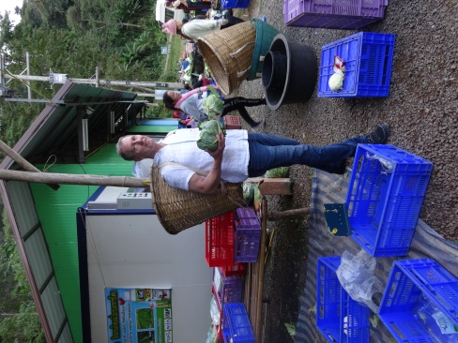
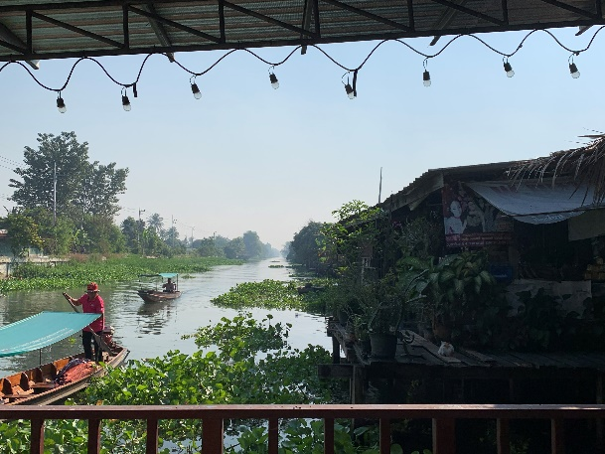
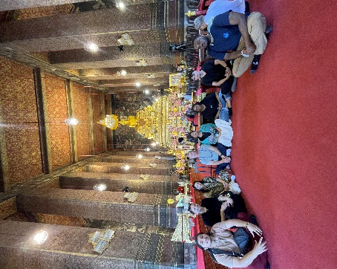

Course period: Winter Session (January 2, 2026 to January 17, 2027)
Students enrolled will be required to meet three times (≤2 hours) prior to departure

Credits: Three (3) credits

Pre-requisites: General Biology and/or General Chemistry (minimum one semester of each). Permission of the instructor. Minimum GPA: 3.00

Faculty Director: Karl R. Matthews, Ph.D. Matthews@sebs.rutgers.edu

Course Objective: This course is designed to appreciate the nexus of food sustainability, food security, and food safety. Students will be exposed to everyday life in Nakhon Pathom, Kanchanaburi, and Phra Nakhon Si Ayutthaya. The rich Thai culture will be highlighted across the rural to urban landscape rooted in over 2500 years of tradition. Students will learn the pathway of foods from: farm to processing, warehousing to transport, and retail (open market, supermarket, street vendor, and restaurant) to table.
By the end of this course, students will be able to:
- Analyze global food systems through the lens of sustainability, safety, and security by tracing the full food pathway—from farm to processing, distribution, and consumption—across multiple cultural contexts in Thailand.
- Collaborate with international peers (including students from Mahidol University) to exchange knowledge and engage in team-based, cross-cultural educational activities that promote global understanding and ethical decision-making.
- Apply principles of sustainable change-making by examining and critiquing real-world food production practices in both rural and urban Thai settings, integrating traditional ecological knowledge with modern food system challenges.
- Design context-sensitive solutions to complex food system issues by incorporating cultural norms, economic constraints, and environmental factors into food product development and transportation planning.
- Demonstrate leadership in cross-cultural settings by participating in hands-on projects and reflective discussions that require them to organize, contribute to, and sometimes lead diverse teams in achieving shared sustainability goals.

Course Requirements and Grading
- Students will be provided required reading material prior to and during the course that will be used to facilitate discussion and development of discussion and critical thinking questions which will count toward the grade (30pts).
- Students will maintain a log/blog starting on arrival in Thailand. The log/blog will be will be evaluated as part of the grade (15pts). Students should consider experiences related to the culture, people, foods, and academic activities. Students may wish to have discussions with students at each of the Mahidol University campuses to understand student life at each campus.
- Student presentation (40pts)
- After return to the US students will be required to submit a course “debrief” incorporating discussion on knowledge gained – academic and cultural, course structure, Thailand – expectation vs reality. (15pts)

GRADING FOR THE COURSE
 | SUBMISSION |  | TOTAL POINTS
1 | Log/blog of Visits/Activities |  | 15
2 | Readings & Participation |  | 30
3 | Debrief Paper |  | 15
4 | Presentation |  | 40
TOTAL POINTS FOR THE COURSE |  |  | 100

Health Equity Minor
This course fulfills the requirements for the undergraduate minor in Health Equity. The Health Equity minor prepares students to analyze and address health disparities, social determinants of health, and health inequalities through an interdisciplinary lens. For more information or to apply for the minor, please visit https://go.rutgers.edu/HEMinor. The Health Equity minor focuses on applying content specific to housing, food insecurity, and education, and is distinct from the Health and Society minor in the Department of Sociology. The Health Equity minor may interest SAS students majoring in Sociology, who are not eligible for the Health and Society minor, and students interested in policies to address health inequities.

Attendance and Participation
Students are required to participate in all detailed activities as outlined in the course schedule. Ample free time is available for students to engage in activities on their own.

Disciplinary policy
Students are expected to conduct themselves in an appropriate manner throughout the trip. In short, there is a zero-tolerance policy for student misbehavior while on this trip. Disciplinary action, including receiving a failing grade in the course and potential for immediate return to the US, will be taken as appropriate. Rutgers academic integrity policy (http://academicintegrity.rutgers.edu/) must be abided by when preparing course work.

- Bangkok Grand Palace Google Maps
- Thonburi Fresh Market Google Maps
- Bang Pa-in Palace Google Maps
- Wat Niwet Thammaprawat Google Maps
- Ayutthaya Historical Park Google Maps
- Pathomsuk Regenerative Farm Google Maps
- Don Wai Market Google Maps
- Exofood Google Maps

